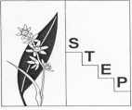
Southern Tablelands Ecosystems Park (STEP)
A regional botanic garden, education and conservation centre
for the Southern Tableland
Flowering in late October November at STEP, Forest 20, National Arboretum Canberra
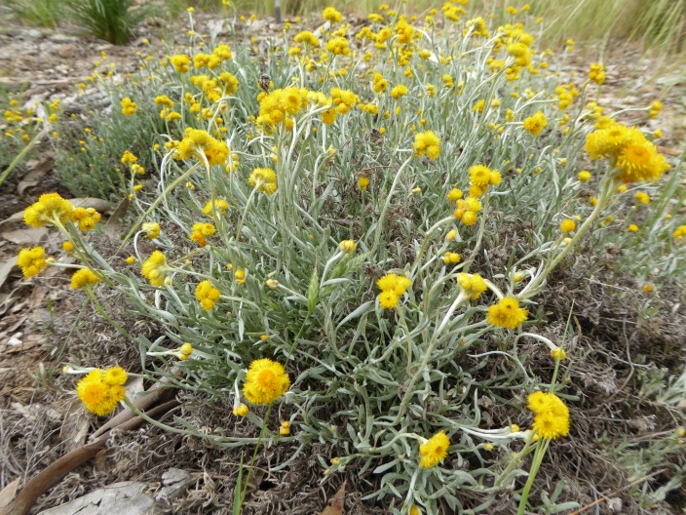  Chrysocephalum apiculatum, Comm. everlasting | 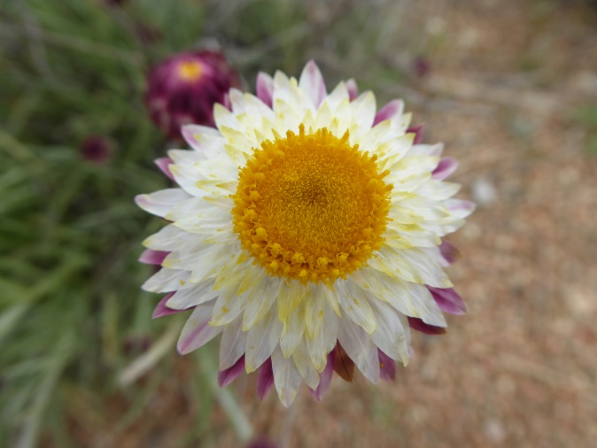  Leucochrysum albicans, Hoary sunray
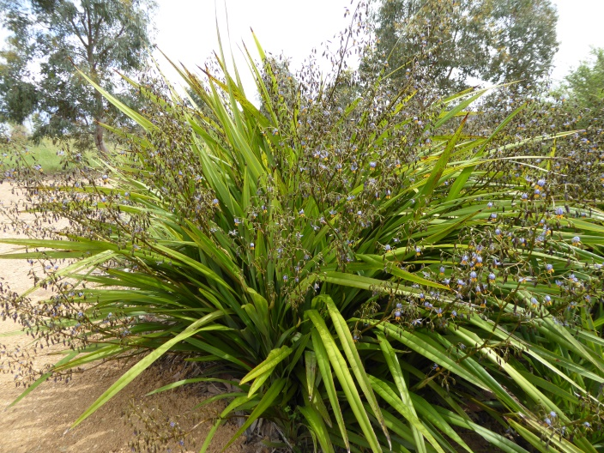  Dianella tasmanica, Blue flax lily | 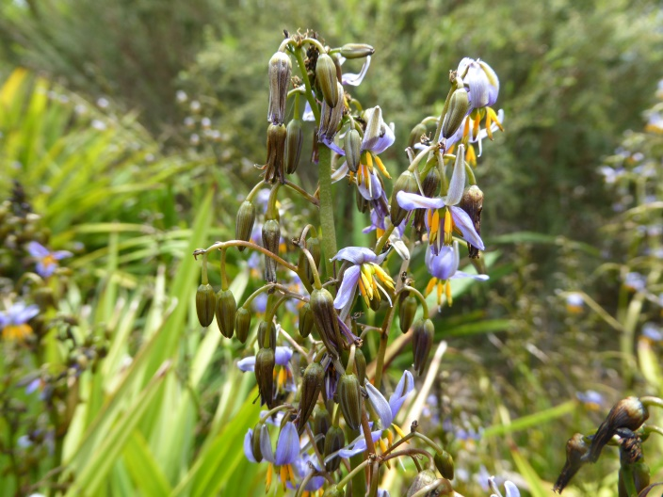  Dianella tasmanica, Blue flax lily
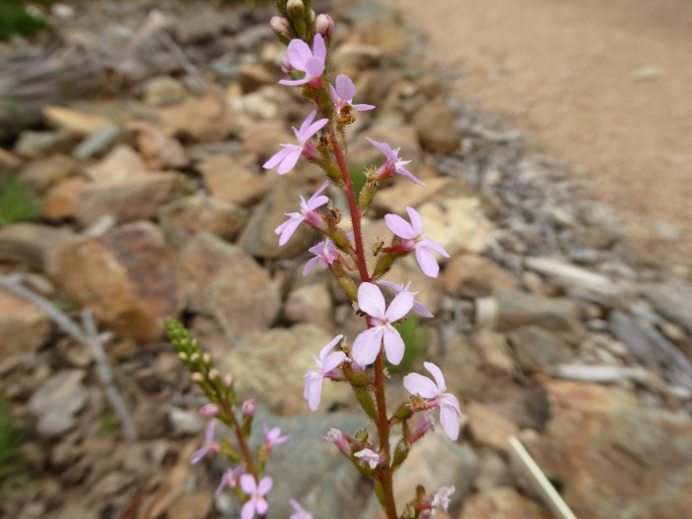 | 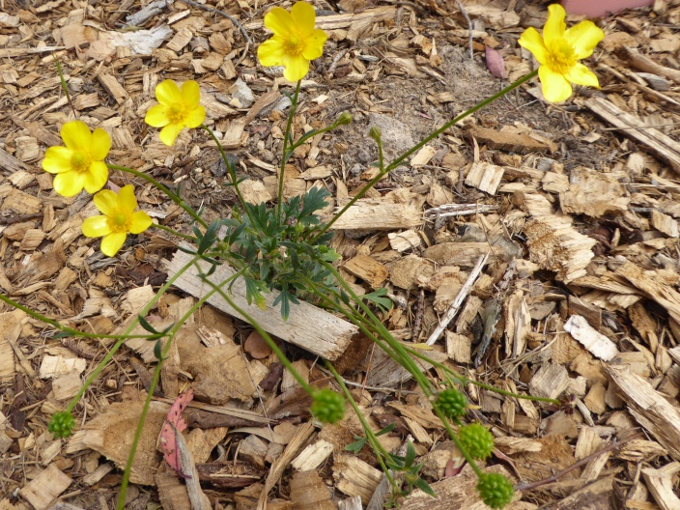
Stylidium graminifolium, Grass triggerplant | Ranunculus lappaceus, Common buttercup
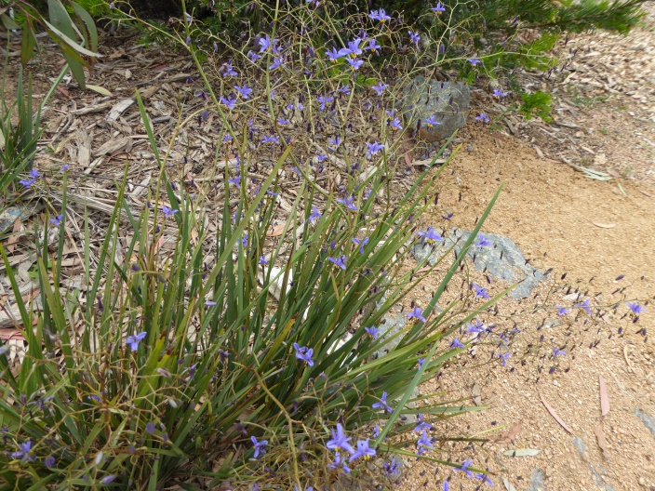 | 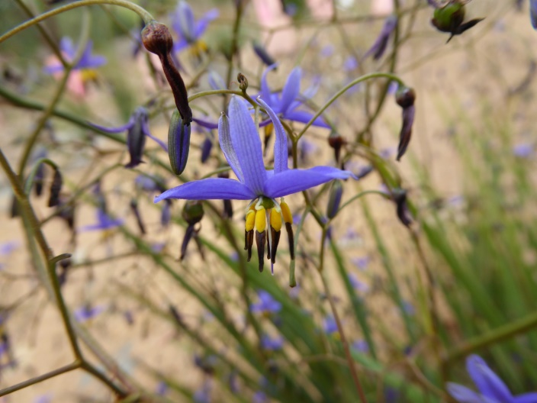
Dianella revoluta, Spreading flax lily | Dianella revoluta, Spreading flax lily
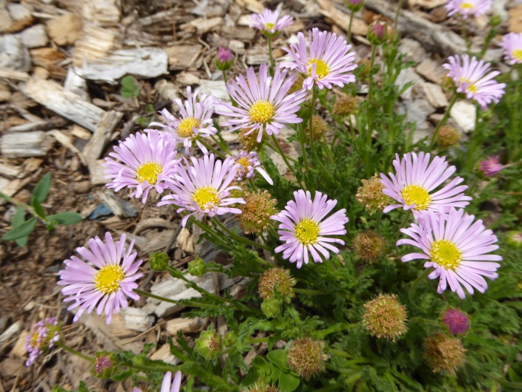  Calotis glandulosa, Mauve burr-daisy | 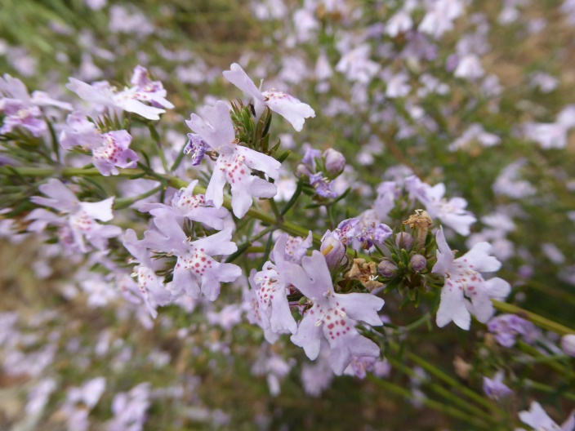  Westringia eremicola, Slender Westringia
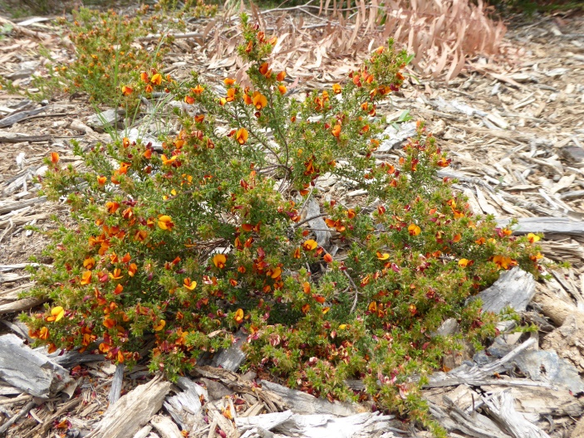  Pultenaea procumbens,Heathy bush pea | 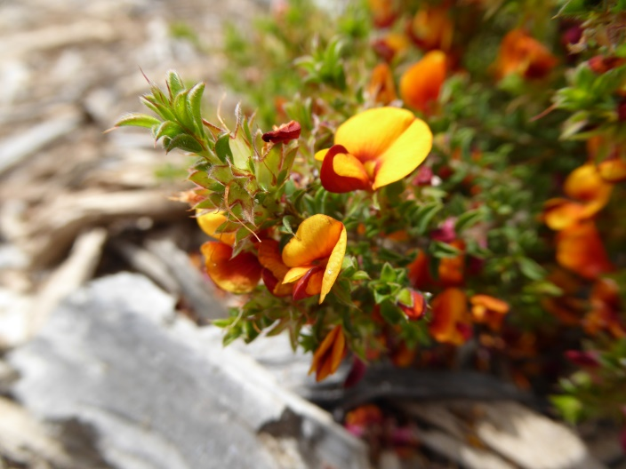  Pultenaea procumbens, Heathy bush pea

Photos and text by Andy Russell Contact STEP: PO Box 440, Jamison Centre ACT 2614 Email membership@step.asn.au Web http://www.step.asn.au/

