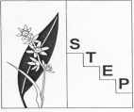
Southern Tablelands Ecosystems Park (STEP)
A regional botanic garden, education and conservation centre
for the Southern Tablelands

Flowering in September at STEP, Forest 20, National Arboretum Canberra
Acacia dealbata, Silver Wattle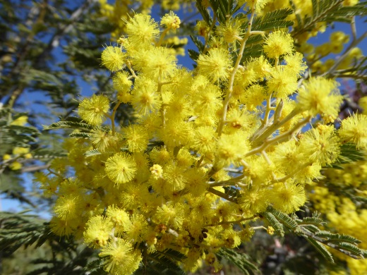 | Hardenbergia violacea, False Sarsaparilla  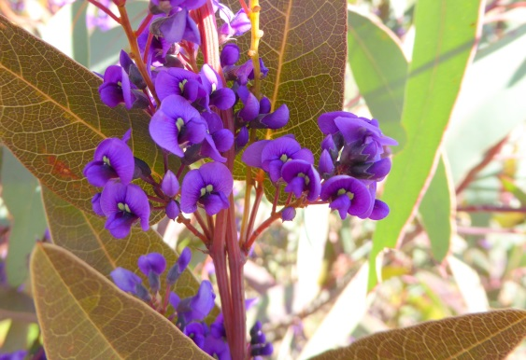
Acacia paradoxa, Kangaroo Thorn  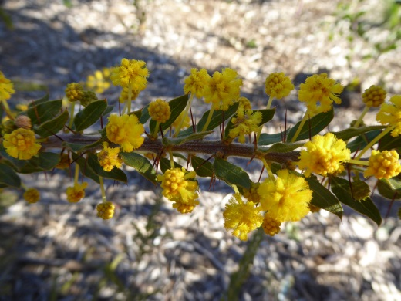 | Acacia genistifolia, Early Wattle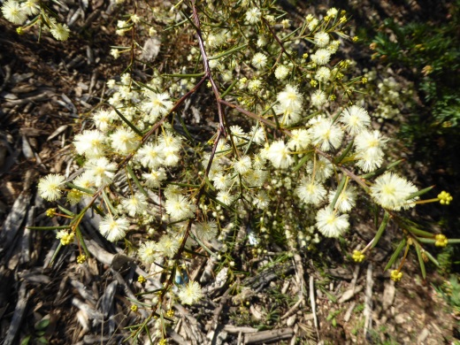
Acacia penninervis, Mountain Hickory  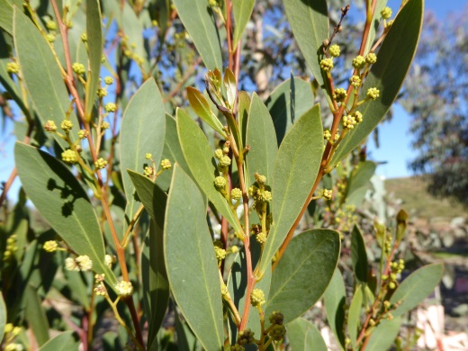 | Acacia pravissima, Ovens Wattle  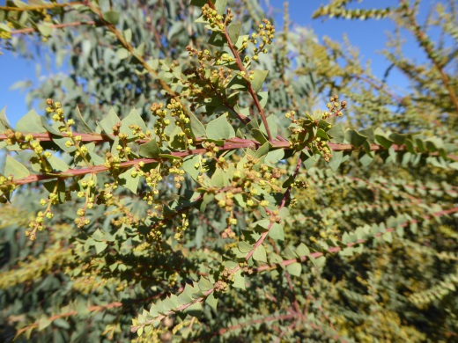
Acacia rubida, Red-leaved Wattle  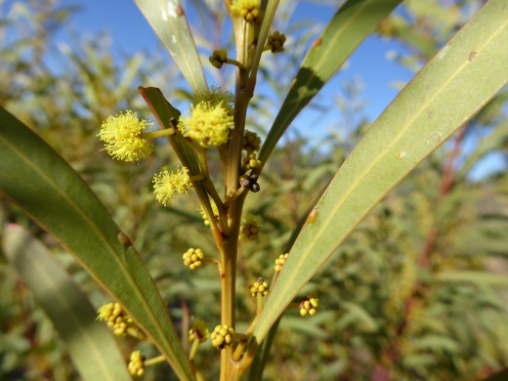  Photos and text by Andy Russell | Acacia siculiformis, Dagger Wattle  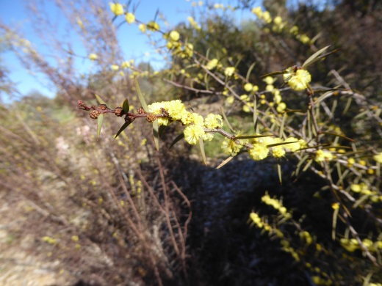

Contact STEP: PO Box 440, Jamison Centre ACT 2614
Web: step.asn.au/

